Julio Barros
What were the names of the access points found? Provide screenshot of the Protocol Hierarchy.
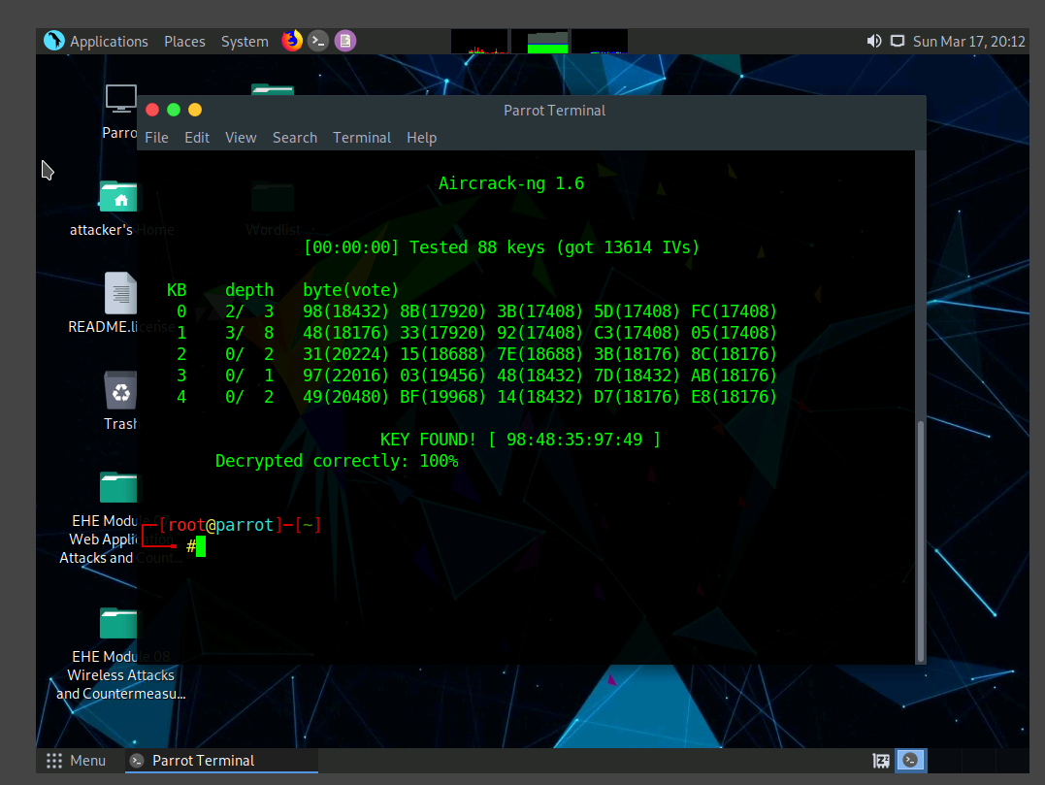

What WEP and WPA2 credentials did you fine? Also, provide a screenshot of the results.
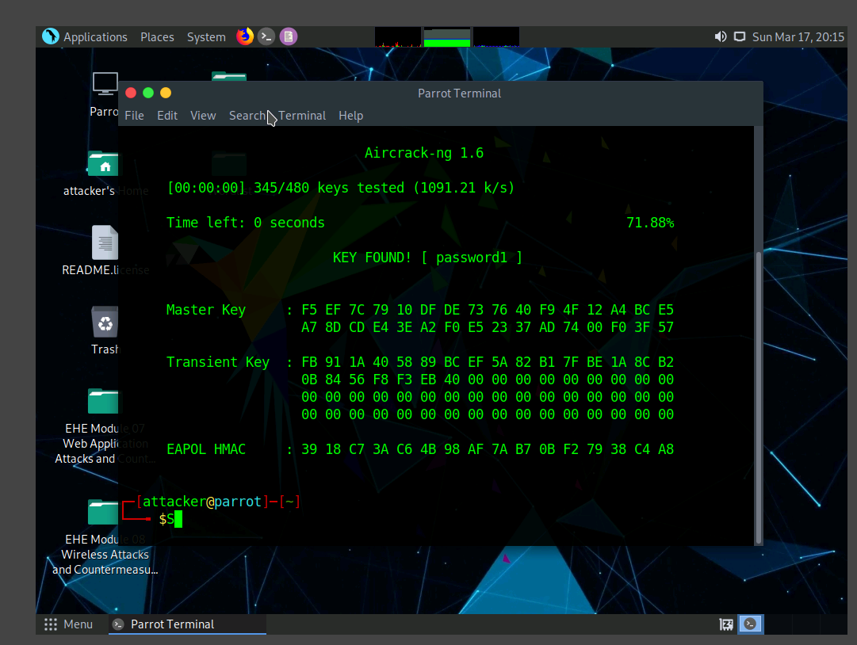

- What worked well in the lab?
Yes it was a great experience using this lab, the instructions were clear and easy to follow.
- What parts were troublesome?
No.
- Over all impression of the lab?
It was my first time using the Aircrack-ng and it surprised me how easy is to get info using the Wireshark cap.

